Project Design Phase
Solution Architecture

Date | 15 February 2025
Team ID
Project Name | Book Store
Maximum Marks

Solution Architecture:
Solution architecture is a structured process that bridges the gap between the business needs of an Online Book Store and the technology used to implement it. It provides a clear blueprint of how different components of the system interact to deliver a secure, reliable, and user-friendly online book shopping experience.
The goals of the solution architecture are to:
- Identify the most suitable technology stack (React.js, Node.js, Express.js, MongoDB) to develop an efficient and scalable Online Book Store.
- Describe the overall structure and behavior of the application, including how customers, sellers, administrators, the frontend, backend, and database communicate with one another.
- Define the core features, development phases, and system requirements, such as user authentication, book management, search and filtering, shopping cart, order management, secure payment, and order tracking.
- Provide a clear architectural blueprint that guides the design, development, testing, deployment, and maintenance of the Online Book Store, ensuring that the solution meets user needs and business objectives.

Example - Solution Architecture Diagram: 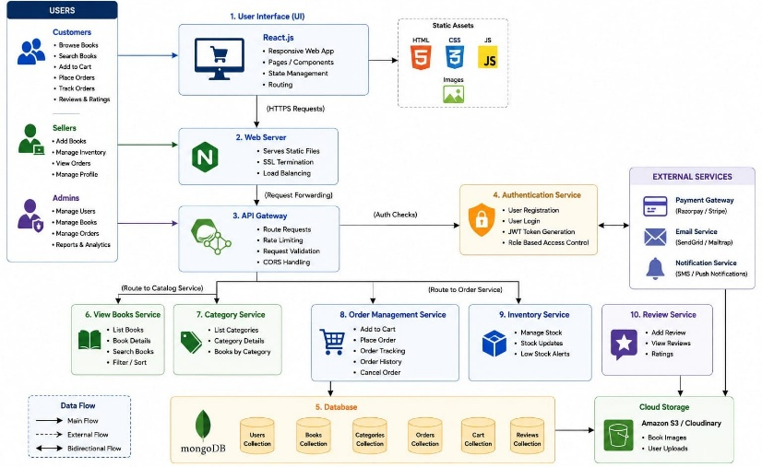

Figure 1: Architecture and data flow of the voice patient diary sample application
Reference: C:\Users\spras\OneDrive\Pictures\62a560ab-0ee3-4ca5-9ac1-3b7a203eb4ad.png

